We thank the reviewers and the editor again for their time and expertise considering this study. For your convenience, the responses are in bold, and specific changes in the manuscript are noted in red. Reference numbers in this response correspond to the bibliography in this document.

**Reviewer 2**:

There remains some issues with the use of dexamethasone.  
The attempt to provide rational for use of dexamethasone has not convinced me of the utility of this approach.  
All provided refs for dex in pregnancy (8-11 in the response section) deal with the consequences of dex admin on pregnancy/placenta/offspring, and are much more in line with my original comment that dex administration is avoided during pregnancy because of its adverse effects. They do not equate dex=stress.  
The claim in the rebuttal that "dexamethasone … not subject to HPA downregulation" is incorrect. Dexamethasone is used clinically for precisely its ability to potently supress cortisol levels in humans ("dexamethasone suppression test"), and it functions similarly in mice See <https://www.sciencedirect.com/science/article/pii/0022395694900310> fig 1, significant cort suppression is achieved 6hrs after dosing at 1mg/kg and maximal effect was achieved at 2mg/kg in mice. Dex is a potent, long acting (>36hrs) drug, so exposure to dex is exacerbated compared to this example article when dosed in an ongoing manner. Given that in the current study dex was dosed in drinking water, exact dosing at 1mg/kg/day may not have been achieved, therefore without circulating cort and ACTH levels it cannot be concluded that the HPA axis was not chronically downregulated by this dosing regimen.

**We agree, and do not mention HPA downregulation in the revised manuscript.**  
  
Dex administration is not equivalent to endogenous release of cort, which is pulsatile, cyclic and responsive to environmental factors. Use of dex may tell you things about the HPA axis, but it does not tell you things about 'stress'. This section needs to be written in terms of 'loss of glucocorticoid signalling', and not rely on a false equivalency of dex=stress. Alternatively, the dex experiments could be removed. The take home is dex causes insulin resistance in pregnant mice, which is not associated with GDF15. I do not believe this data has broader implications for GDF15 without much more detailed investigation and it does not add substantially to the rest of the manuscript.

**We agree with this critique and have removed all direct equivalencies of dexamethasone with stress. We are now more explicit that this is in terms of glucocorticoid excess. Specifically revisions include**

**Keywords: replaced stress with glucocorticoids**

**lines 107-113**

**“Comparisons between non-pregnant and pregnant individuals and between healthy versus chronic glucocorticoid elevations during pregnancy are understudied in murine models Given the sometimes-conflicting human data we sought define the effects of *Gdf15* loss of function during the course of healthy murine pregnancy, including effects on weight gain, food intake, insulin sensitivity, and neonatal outcomes. We also evaluated GDF15 in circulation to understand differences based on physiological state and complications from exogenous glucocorticoids induced insulin resistance.”**

**250-252**

**“We sought to model the contributions of GDF15 and glucocorticoid excess on insulin resistance of pregnancy and understand if GC excess would increase GDF15 levels.”**

**We also added a clarifying statement in the discussion distinguishing glucocorticoid excess from normal pulsatile release of glucocorticoids or models of chronic stress.**

**435-439**

**“Our data demonstrating a lack of GDF15 induction in dexamethasone-treated dams does not support a role of exogenous glucocorticoid excess on GDF15 levels in pregnancy, but does not clarify to the role of endogenous corticosterone elevations due to chronic psychosocial stress, which involves circadian and intermittent inductions of the HPA axis, unlike our model which is a chronic high-dose elevation of glucocorticoids during pregnancy. “**

Figures with individual data points should have the points in a different colour to the background bar. Black on black in 2c makes half the data points invisible.

**We agree and have changed the color for data points so they are clearly visible in figure 2c, 2f (shown below), and supplemental figure 1.**

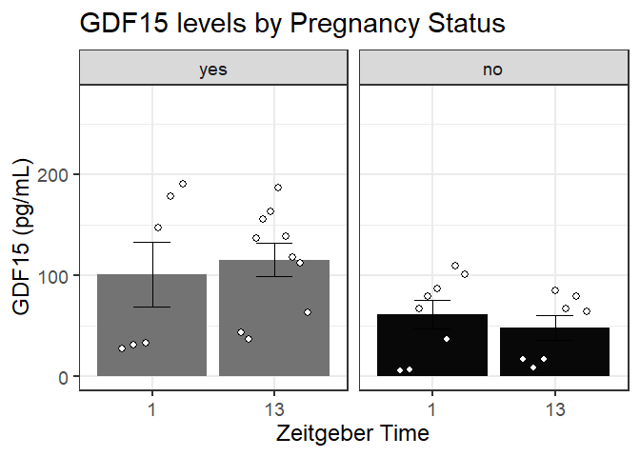

RWT figure 2 - I am happy for A and D to remain as %change from baseline, as long as the raw values are presented in the sups.

**We included the raw glucose values in supplemental figure 2 b and d.**

**